Hw06

Problem 1:

Last week, we talked about algorithms for constrained optimization, in projected gradient descent, we first convert a constrained problem to an unconstrained problem by adding indicator function, since indicator function is unsmooth, we can solve it by projected gradient descent. The second method is barrier methods, we add a function into the origin problem. The third method is primal dual interior point method. Then we talked about dual ascent method and dual decomposition. After that, we talked about MoM. The difference between MoM and dual ascent is that MoM uses augmented Lagrangian of origin problem. It has better convergence but can’t be separable. Then we talked about ADMM and how to implement ADMM in distributed system.

Problem 2:

Problem 3:

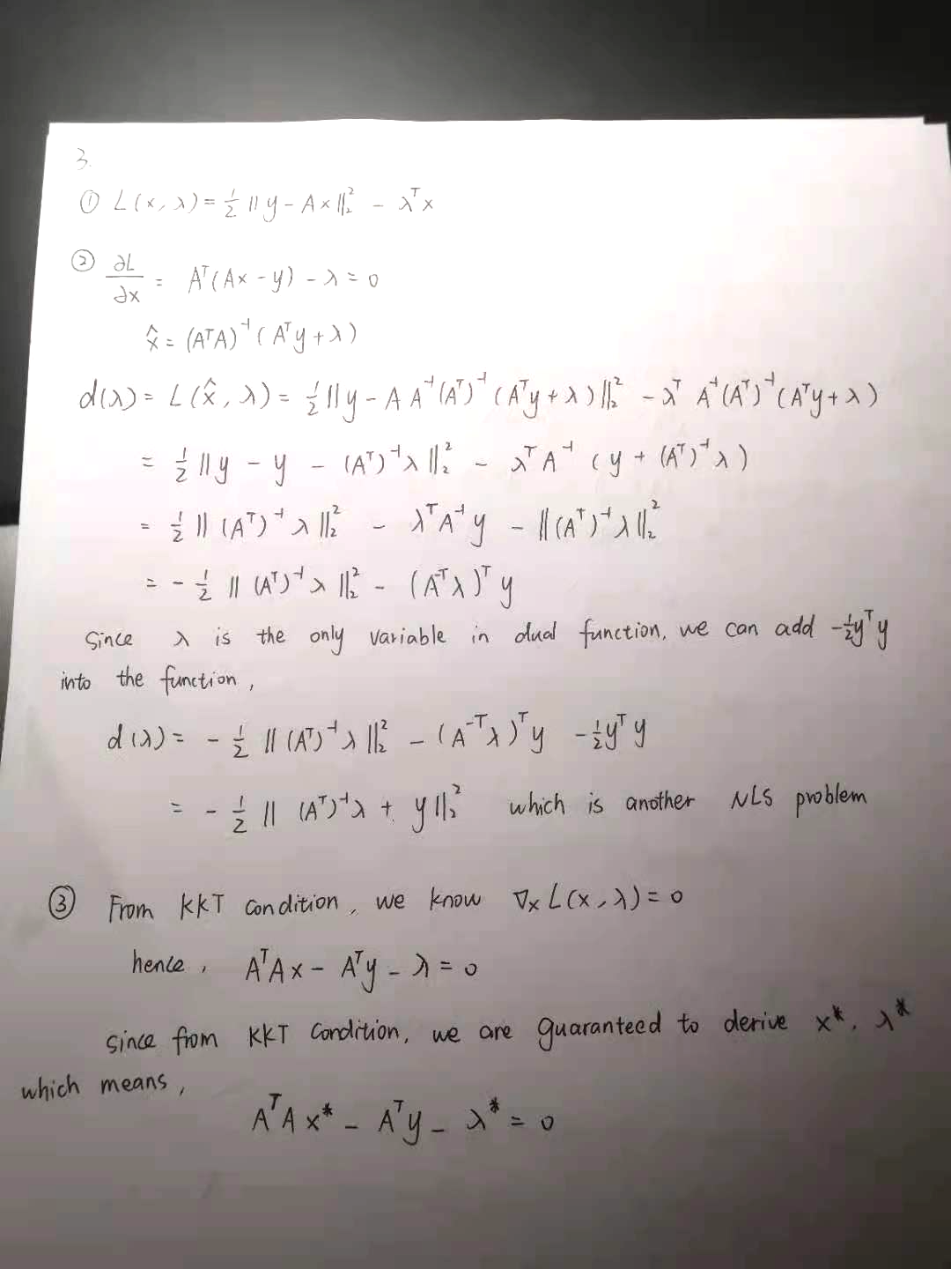

Problem 4:

Problem 5:

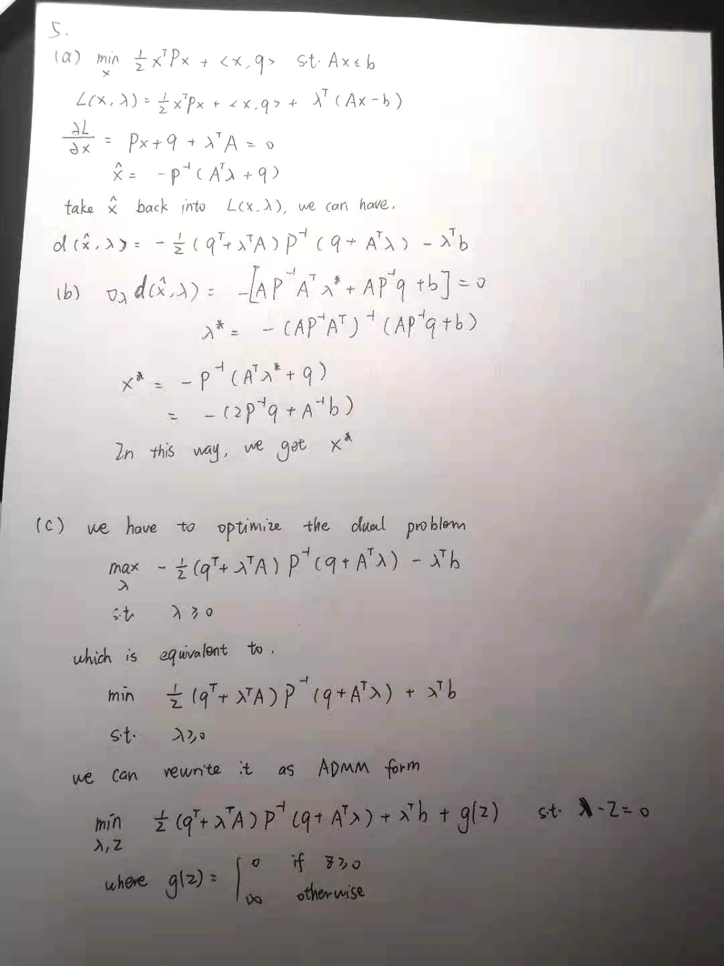

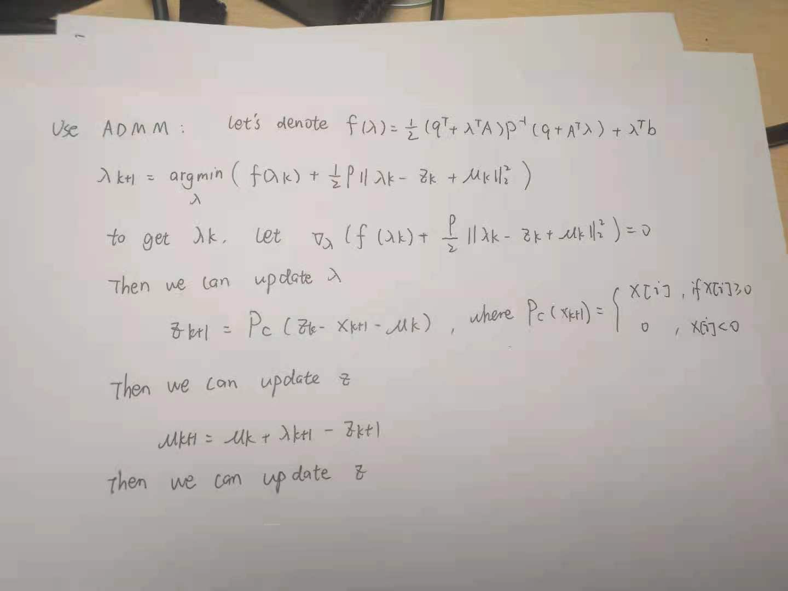

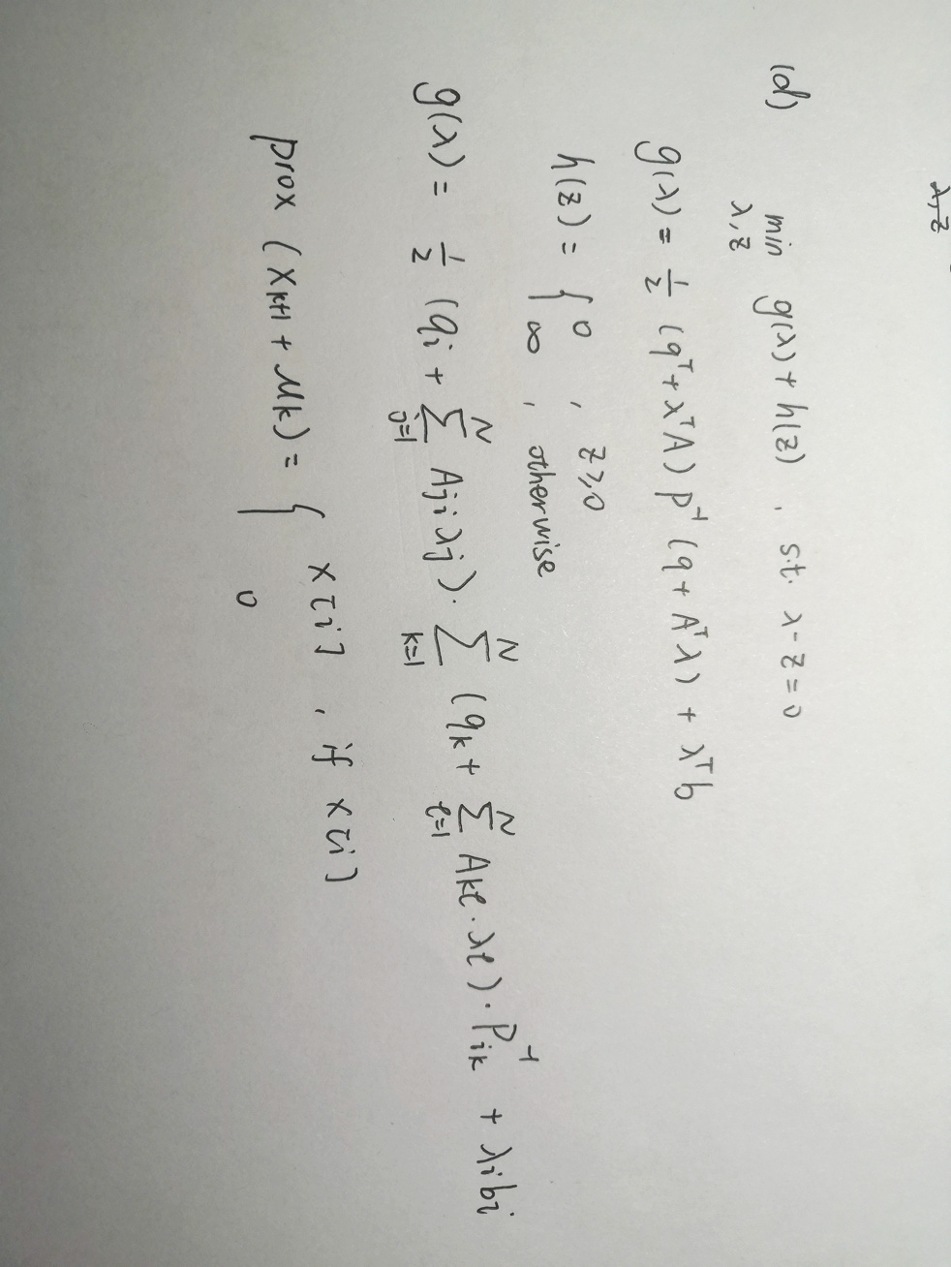

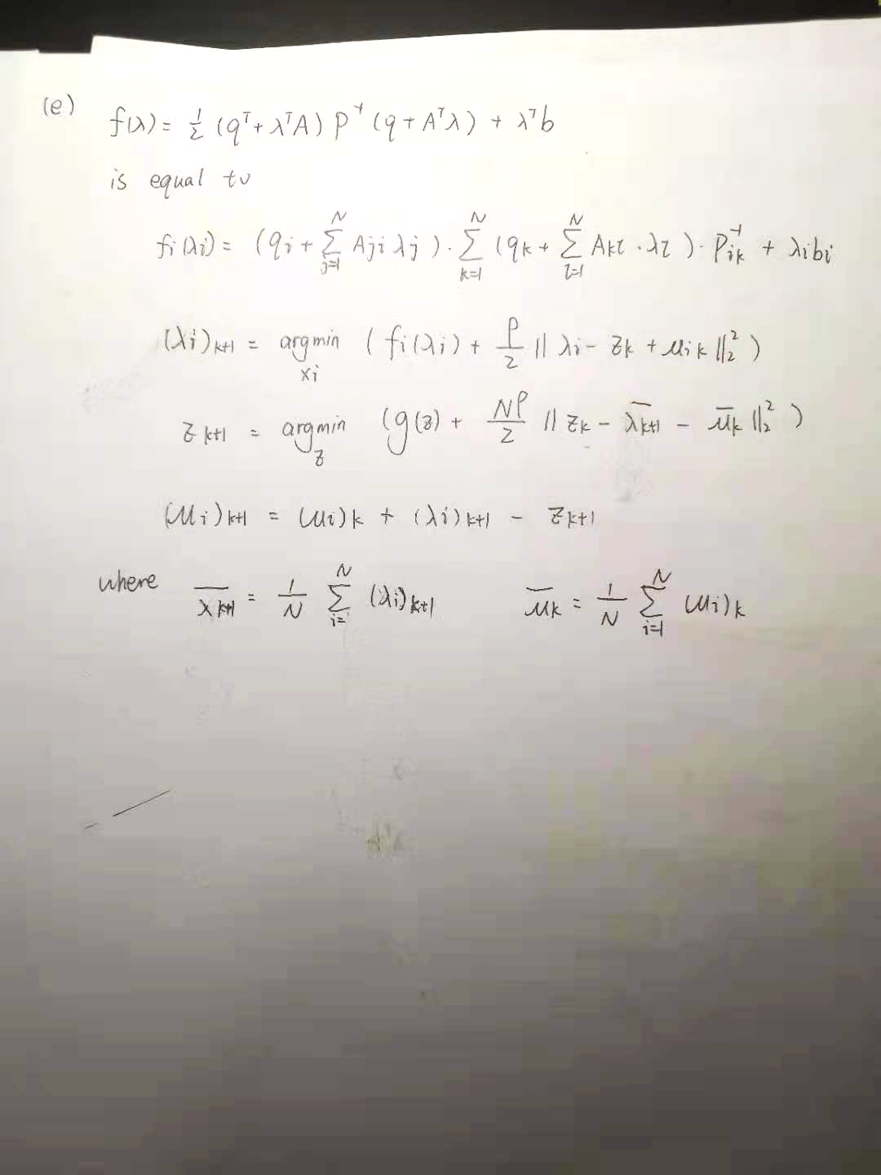

Problem 6

